Kunhui Zhang (001563549)

**Program Structures & Algorithms**

**Fall 2021**

**Assignment No. 3 (WQUPC)**

* **Task (List down the tasks performed in the Assignment)**

Step1:

1. Implement the class UF_HWQUPC, by finishing three methods: find(), mergeComponents() and doPathCompression().
2. Run and pass the unit tests UF_HWQUPC_Test.

Step2:

Using the class UF_HWQUPC, create a new program named UFclient that takes an integer value n from the command line to determine the number of "sites." Then generates random pairs of integers between 0 and n-1, calling connected() to determine if they are connected and union() if not. Loop until all sites are connected then print the number of connections generated. Package this program as a static method count() that takes n as the argument and returns the number of connections; and a main() that takes n from the command line, calls count() and prints the returned value.

Step3:

Run the UFclient.java several times with different n value. Draw the picture of relationship between m(number of connections/pairs) and n(number of sites). Observe the picture and conclude this relationship.

* **Relationship Conclusion: (For ex : z = a * b)**

$$M= \frac{1}{2}Nln(N)$$

M:number of connections/pairs, N:number of sites

* **Evidence to support the conclusion:**

1. **Output (Snapshot of Code output in the terminal)**

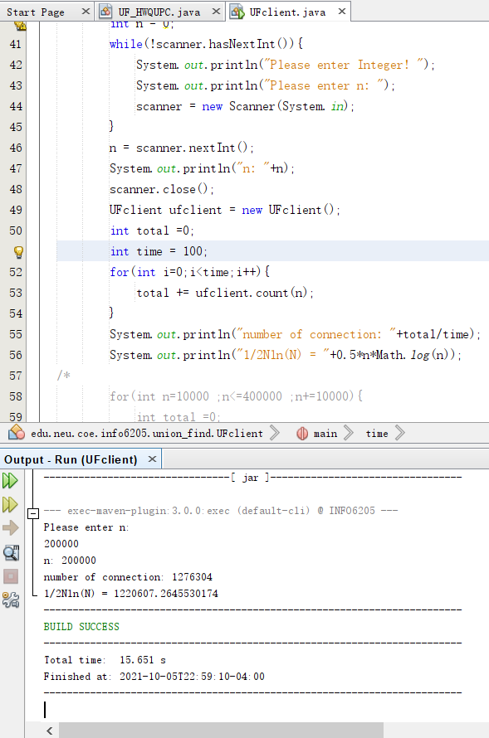

This is one time that I input the number of sites and used UFclient to get the number of pairs. In the meantime, I printed 1/2Nln(N) with M(the number of connection).

The data of my graphical evidence are all gotten by this way.

1. **Graphical Representation(Observations from experiments should be tabulated and analyzed by plotting graphs(usually in excel) to arrive on the relationship conclusion)**

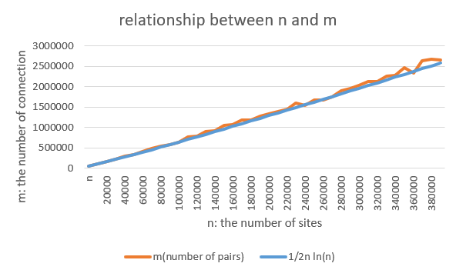

According to the graph above, we could find the relationship between N(number of sites) and M(the number of pairs) is closed to:

$$M= \frac{1}{2}Nln(N)$$

* **Unit tests result:(Snapshot of successful unit test run)**

UF_HWQUPC_Test: 